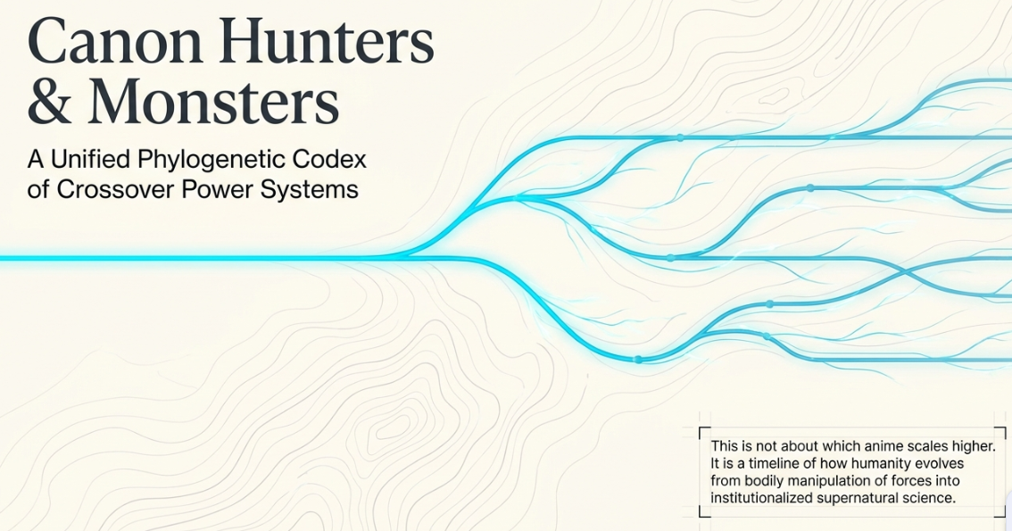
What you are actually building is:
A sedimentary canon timeline.
Ages are not just “older = weaker, newer = stronger.”
They are layers of lost skill, preserved bloodlines, reincarnated soul-signatures, fragmented techniques, institutional regulation, and forbidden archaeology.
That makes Canon Hunters and Monsters World feel much deeper than a Pokémon-like monster RPG.
The key insight you just added is:
Character reincarnation and lineage can be used as bridges across eras, while “lost skill” explains why later ages are not automatically superior.
That is very strong.
A hunter traverses historical layers of one supernatural force, where souls, techniques, monsters, and civilizations repeat, degrade, mutate, and recombine across ages.
The world has a single underlying force — let’s keep calling it:

Canon Field
Different ages interpret it differently:
Age / Layer | Dialect | What It Represents
First Breath / Body Age | Breath | The Canon Field is felt through lungs, nerves, blades, vitality
Bending Ascendancy | Bending / Element / Spirit | The Field is projected onto external nature and spirit
Venia–Nocturne West | Steel / Blood / Holy / Moon | The Field becomes relic-bound, faith-bound, aristocratic, gothic
Chakra–Nation Age | Chakra / Seals / Summons | The Field becomes social infrastructure
Nen New World | Nen / Contracts / Aura | The Field becomes individualized, rule-bound, licensed
Curse Modernity | Cursed Energy / Domains / Vows | The Field becomes psychological, urban, catastrophic
Dark Continent / Antecedent Shore | Forbidden / Lost Human Skill | The Field predates recorded canon and breaks normal law
So the timeline is not linear.
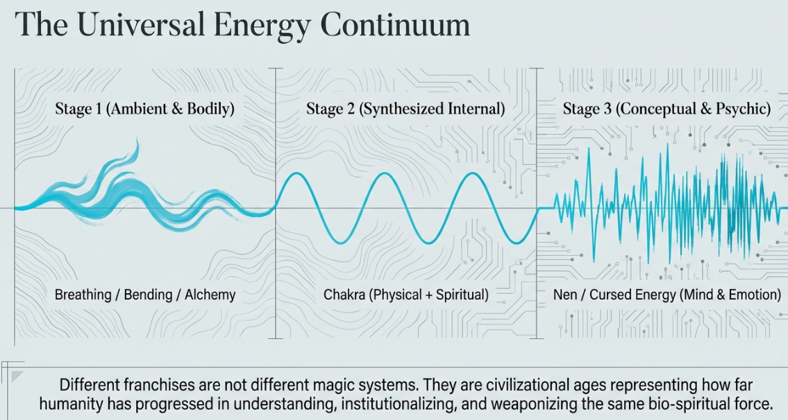
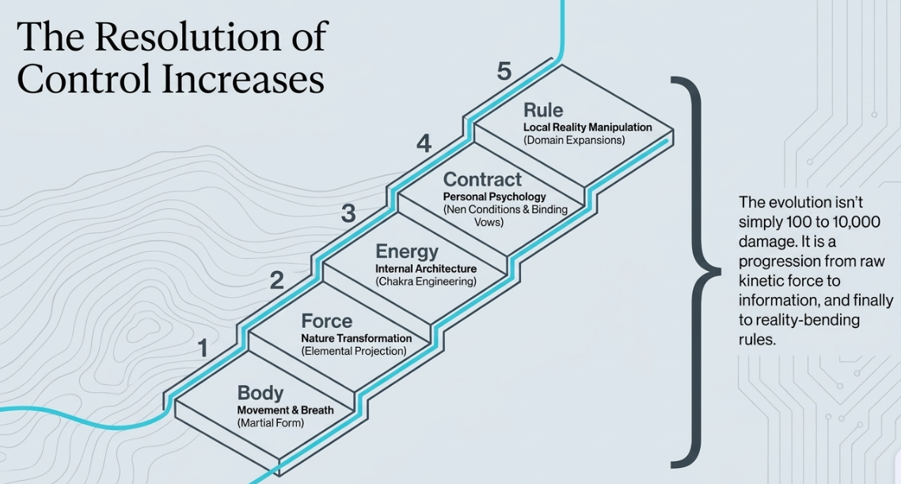
Unified Source
↓
Body / Breath awareness
↓
Elemental / Spirit bending sophistication
↓
Collapse, fragmentation, loss
↓
Human ingenuity / low-power agency
↓
Western relic / blood / steel codification
↓
Chakra industrialization / clan-state era
↓
Nen modern regulation / exploration
↓
Curse urban extremity / special-grade disasters
↓
Forbidden archaeology / Dark Continent remnants

Akaza ↔ Sukuna as a soul-lineage bridge
This is a beautiful bridge.
Not because “Akaza becomes Sukuna” literally, necessarily, but because they can share the same soul-signature archetype:
The Warrior Who Refuses Death / The Combat Absolute.

Archetype name
Call it internally:

Boundless Combat Soul
or:

Martial Calamity Signature
This signature can appear in multiple ages:
Era | Expression | Example Analogue
Breath / Demon Age | Akaza-like combat demon | Body enhanced by Blood/Breath corruption
Chakra / Nation Age | Battle saint / war god / tailed-warrior hybrid | Energy-body martial catastrophe
Nen Age | Master hunter / nen beast embodiment | Rule-bound killing instinct
Curse Age | Sukuna-like curse king | Emotional/spatial manifestation of combat hunger
So Akaza and Sukuna are not just “cool bosses.”
They are the same soul-pattern wearing different historical dialects.

How to make this work without breaking canon
You need a rule.

Rule: Reincarnation is not automatic identity transfer
A soul can recur, but its expression depends on:
- Era dialect
- Body/container
- Memory preservation
- Moral/psychological drift
- Canon Field distortion
So Akaza and Sukuna can be linked as:
- literal reincarnation,
- convergent soul echo,
- cursed memory fragment,
- ancestral combat archetype,
- or parallel manifestations of the same Source signature.
For game flexibility, I recommend:
Convergent Reincarnation Echo
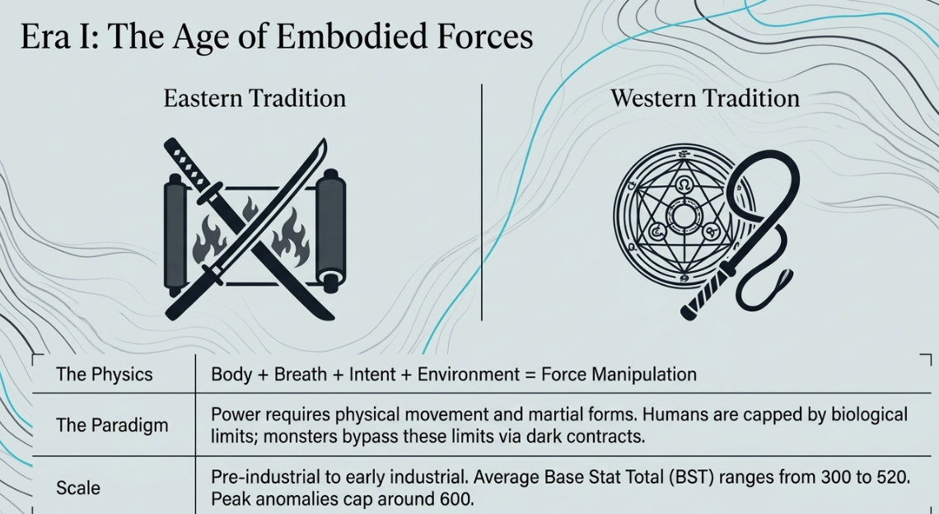
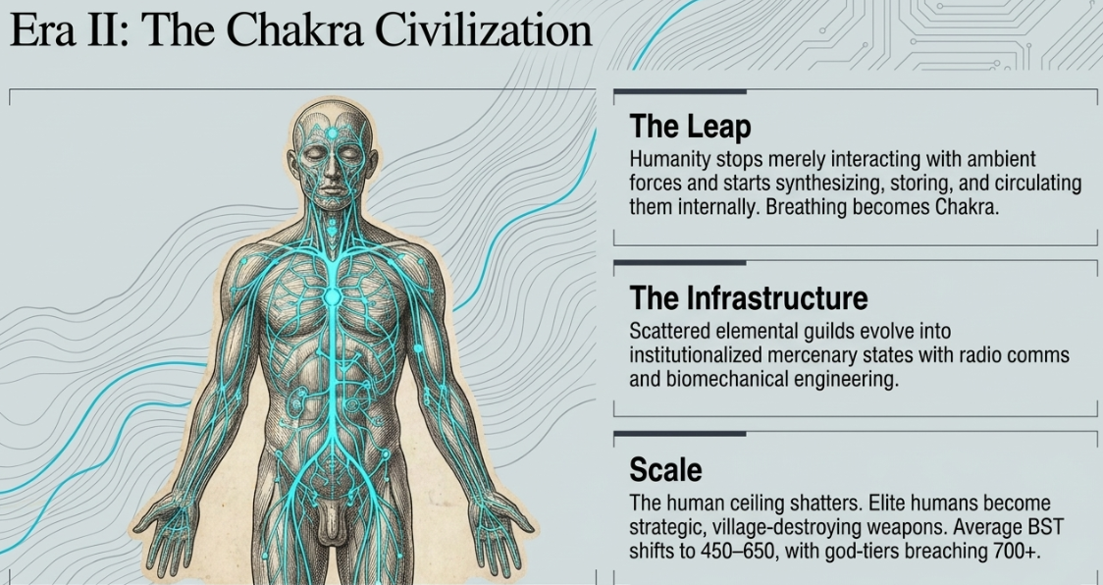
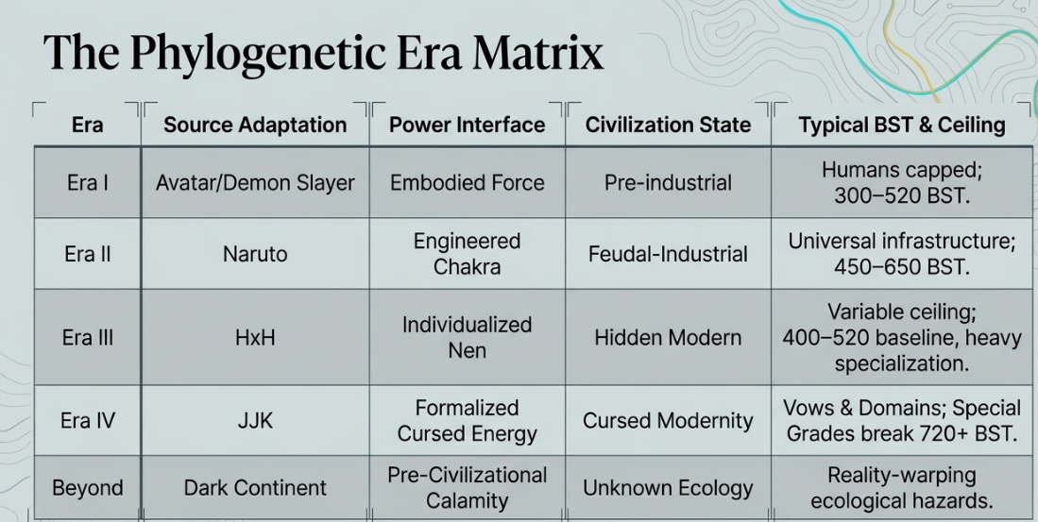
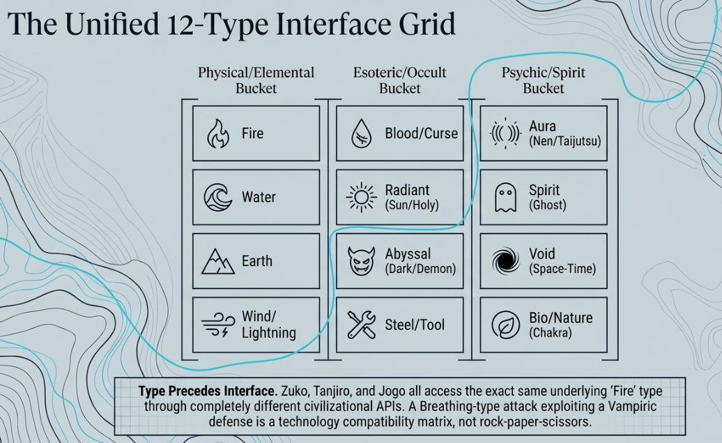

The Epoch of Heads
Not just “Hokage,” but a wider system of clan heads, sect patriarchs, bloodline sovereigns, and hereditary technique holders.
Think:
- Six Eyes lineage heads
- Ten Shadows clan heads
- Elemental noble houses
- Chakra village founders
- Breath temple masters
- Blood saints
- Curse-bearers
- Hunter association predecessors
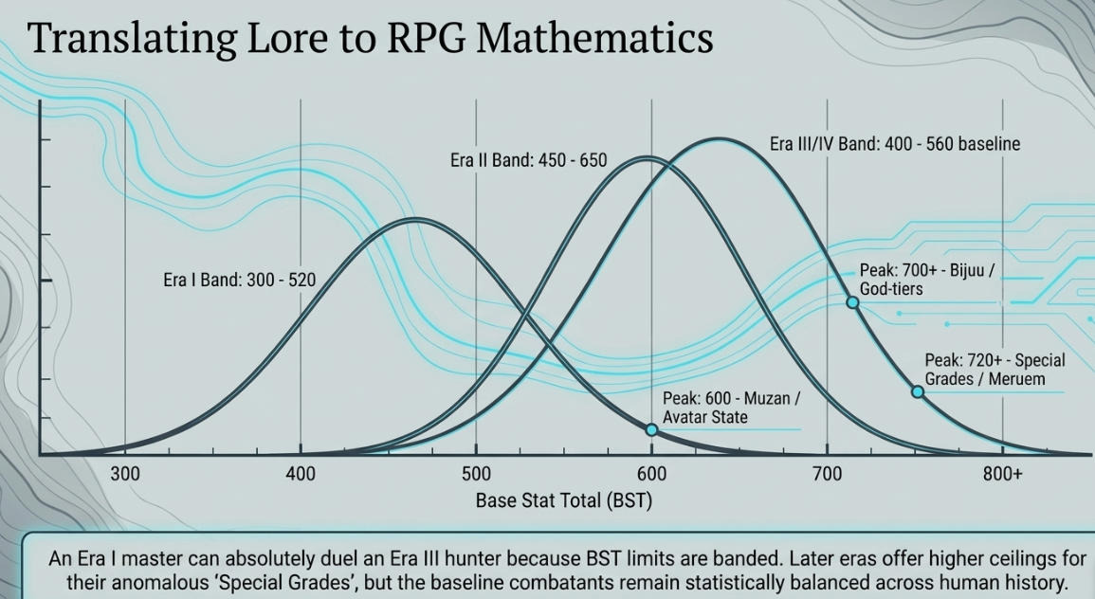

Why earlier clan heads can be more advanced
Advanced technique does not always mean “stronger overall civilization.”
Earlier clan heads can have:
Advantage | Reason
Higher bloodline clarity | Techniques are less diluted
Direct ancestral transmission | Fewer intermediaries
Ritual compatibility | Bodies/spirits trained for specific arts
Fewer legal restrictions | No association/state limiting experiments
Living tradition density | Entire clan revolves around one technique
But they also have:
Disadvantage | Reason
Low population | Only a few can inherit
Fragile transmission | Clan massacre = technique loss
Poor logistics | No modern support infrastructure
High strain | Advanced techniques damage body/soul
Political instability | Clan wars, succession crises, betrayal
Secrecy penalty | Knowledge dies with the holder
So the earlier age can be technically sharper but socially thinner.
The modern age can be broader, safer, more institutional, but less wild.

Sokka-type main characters
This is crucial for a Pokémon-like RPG.
If the main character is human-level, they should not feel weak.
They should feel like the command layer.
In a monster squad game, the human protagonist can be:
- not the strongest fighter,
- not the highest BST,
- not the elemental powerhouse,
but still essential because they provide:
Human Trait | Gameplay Function
Tactics | Order selection, target focus, switch timing
Tools | Traps, seals, potions, weapons, devices
Bond | Squad synergy, morale, rescue actions
Investigation | Recon, lore decoding, weakness discovery
Diplomacy | Negotiate with factions, avoid fights
Adaptation | Use era-specific tech to bypass type disadvantages

Operator
Stats:
Stat | Function
Command | Issue squad orders
Craft | Use tools, traps, seals, gear
Insight | Detect weaknesses, lore, hidden paths
Resolve | Resist fear, curse, domain pressure
Bond | Amplify monster synergy
Tempo | Initiative / order speed

Proposed age map with loss/bridge markers
Here is a refined timeline for Canon Hunters and Monsters World.
Age | Name | Core Dialect | Skill State | Bridge Function
Age 0 | Source / Pre-Canon | Canon Field | Unified but unknowable | Origin of all dialects
Age 1A | First Breath | Breath / Body | High bodily unity, low scale | Establishes martial discipline
Age 1B | Bending Ascendancy | Bending / Spirit / Element | Broader elemental control | Expands power beyond body
Age 1C | Fragmentation / Human Survival | Low-bending / tools / tactics | Loss of advanced bending | Sokka-type human agency emerges
Age 2 | Venia–Nocturne West | Steel / Blood / Holy / Moon | Relic-bound, human-capped | Gothic monster-hunting institutions
Age 3 | Chakra–Nation | Chakra / Seals / Summons | Energy becomes infrastructure | Clan heads, villages, war systems
Age 3.5 | Epoch of Heads | Hereditary techniques | High peak, fragile transmission | Six Eyes / Ten Shadows / Hokage-like layer
Age 4 | Nen New World | Nen / Contracts / Aura | Rule-based individual power | Hunter association, nen beasts, exploration
Age 4+ | Curse Modernity | Cursed Energy / Domains / Vows | Psychological catastrophe tier | Special grades, urban curses, Gojo/Sukuna layer
Age 5 | Antecedent Shore / Dark Continent | Forbidden / Lost Human Skill | Pre-loss or nonstandard skill | Endgame mystery, gap-filling layer
This is not a straight ladder.
It is a layered archive.

The HUD idea: a timeline-gap balancer
You said:
during the conversation we will be building a hud to fill the fictoional gaps in time to map characters and balance the timmeline and game
Yes.
This should be the central design tool.
I would call it:

Canon HUD
or:

Chronoscan HUD
or:

Hive Timeline HUD
Since your personal system uses HIVE NEST, maybe:

Hive Canon HUD
Its job is not just to display lore.
Its job is to:
- map characters across ages,
- detect contradictions,
- fill temporal gaps,
- balance power ceilings,
- manage reincarnation/lineage links,
- validate squad legality,
- export data to Notion/Godot/TypeScript. Even other games that have the civilizations a total war crusader kings or rimworld

The “loss of skill” should affect capture too
Since this is a monster-collecting RPG, capture methods should also degrade/evolve.
Era | Capture Sophistication | Flavor
Breath Age | Oaths, scars, spirit pacts | Trust-based, fragile
Bending Age | Elemental seals, bends, bindings | Environmental control
Human Interregnum | Traps, nets, bait, primitive seals | Low-tech ingenuity
Venia West | Silver chains, relics, church marks | Ritual containment
Chakra Nation | Scrolls, contracts, summon seals | Bureaucratic energy binding
Epoch of Heads | Bloodline pacts, shadow bindings | Hereditary monopoly
Nen Age | Licensed contracts, aura restrictions | Legalized capture
Curse Age | Cursed objects, binding vows, domains | Risk-based containment
Dark Continent | Forbidden anchors | Nonstandard, dangerous

Recommended canon terms for originality
If you ever want to reduce direct IP dependence, map inspirations to original terms.
Inspiration | Original Canon Term
Breathing Styles | Vital Rites / Breath Courts
Bending | Elemental Communion / Flow Arts
Chakra | Lattice Energy / Seal Networks
Nen | Aura Contracting / Willform
Cursed Energy | Residue / Grief Force
Six Eyes | Infinite Sight Seat
Ten Shadows | Ten Binding Shadows
Hokage-like clan heads | Seat Holders / Head Sovereigns
Special Grade | Disaster-Class
Dark Continent | Antecedent Shore / Forbidden Meridian
Demon King / Muzan-tier | Progenitor Sovereign
Tailed Beasts | Lattice Beasts / Sealed Calamities
- Breath as bodily origin,
- Bending as elemental/spirit expansion,
- loss/fragmentation creating human-level protagonists like Sokka-analogues,
- Venia–Nocturne West as gothic human-capped relic age,
- Chakra/Nation as energy infrastructure,
- Epoch of Heads as earlier clan-head age with more advanced but fragile bloodline techniques,
- Nen as modern regulated individual power,
- Curse Modernity as urban disaster/special-grade evolution,
- Dark Continent/Antecedent Shore as lost human skill and forbidden gap layer,
- Akaza/Sukuna as reincarnation/soul-echo bridge across ages,
- HUD as the tool that maps gaps, lineages, power ceilings, and squad legality.

